Academic Year 2026-27
FY MCA- SEM I
IT11 PYTHON
Practice Assignment1

Roll No: 2601196
Name: Ashutosh Uttekar

- Write a program to read a file and count how many vowels are present in its content.

Code : 01.py

with open("01.txt", "r") as file:
content = file.read()
vowels = "aeiouAEIOU"
count = 0

for char in content:
if char in vowels:
count += 1

print("Number of vowels in the file:", count)

01.txt
HELLO
MY NAME IS ASHUTOSH
FY-MCA
2601196

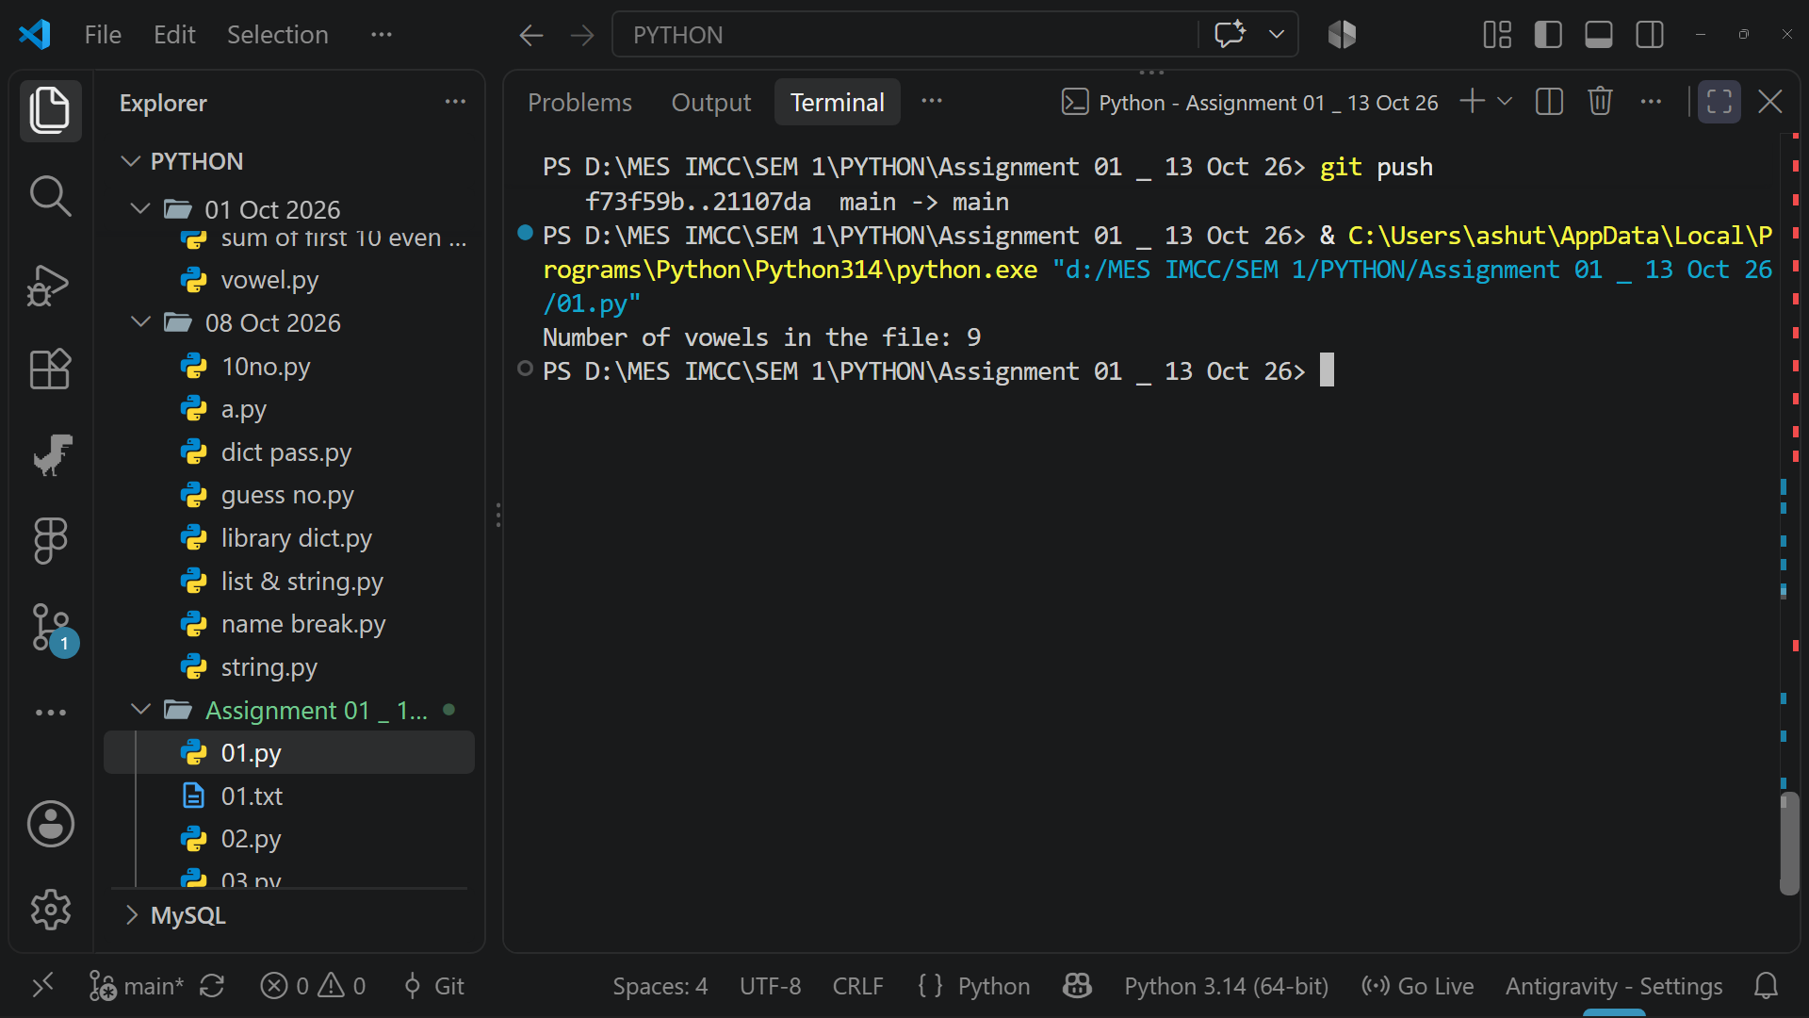
- Read all lines from a file into a list. Print the total number of lines and display the 2nd and 4th line.

02.py

with open("01.txt", "r") as file:
lines = file.readlines()
total_lines = len(lines)
print("Total number of lines:", total_lines)
if total_lines >= 4:
print("2nd line:", lines[1])
print("4th line:", lines[3])
else:
print("The file does not have enough lines.")

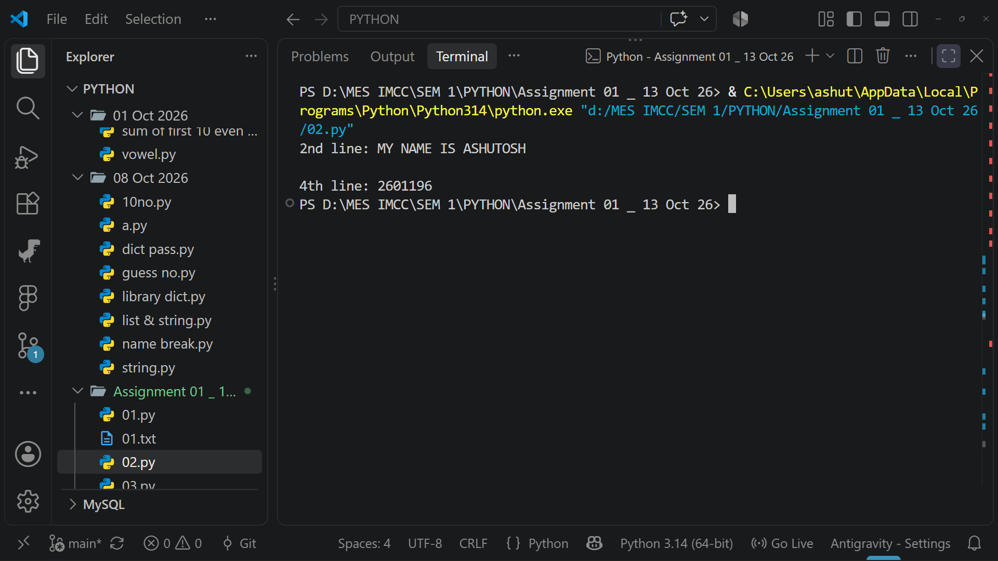

- Take a sentence from the user, split it into words, and store them in a list. Print the longest word.

03.py

sentence = input("Enter a sentence: ")
words = sentence.split()
longest_word = max(words, key=len)
print("The longest word is:", longest_word)

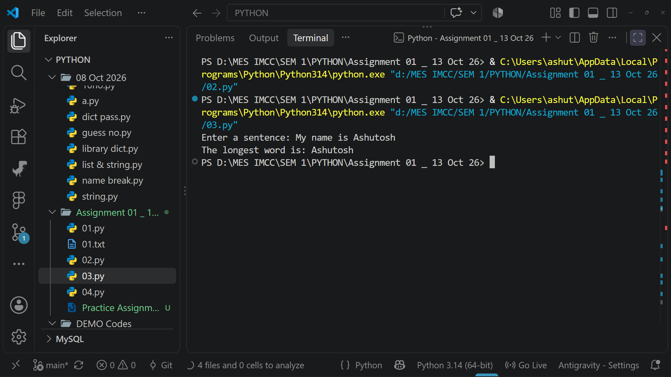

- Read a file, split its content into words, and store them in a list.
    - Print the total number of words.
    - Print all unique words.

04.py

with open("01.txt", "r") as file:
content = file.read()
words = content.split()
total_words = len(words)
unique_words = set(words)

print("Total number of words:", total_words)
print("Unique words:", unique_words)

